# CS 255 System Design Document Template

This template lays out all the different sections that you need to complete for Project Two. Each section has guidance to prompt your thinking. You will need to continually reference the interview transcript as you work to make sure that you are addressing your client’s needs. There is no required length for the final document. Instead, the goal is to complete each section based on what your client’s needs are. Remove this note when you are finished, and replace all bracketed text with the relevant information.

## UML Diagrams

### UML Use Case Diagram

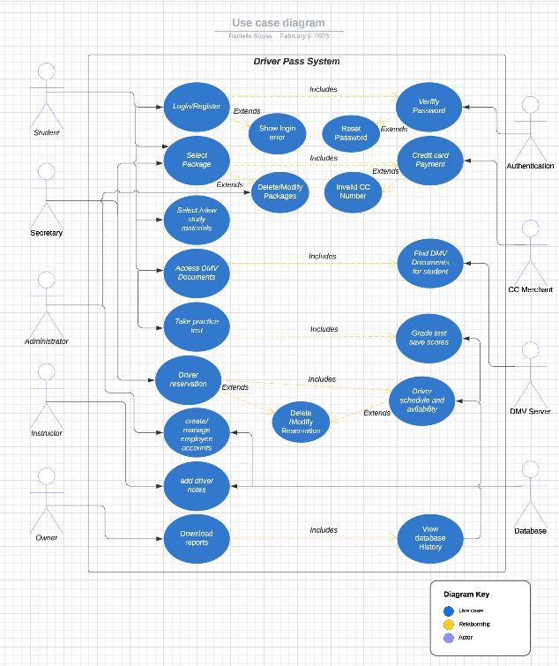

### UML Activity Diagrams ( Login)

### UML Activity Diagrams ( Reservation)

### UML Sequence Diagram

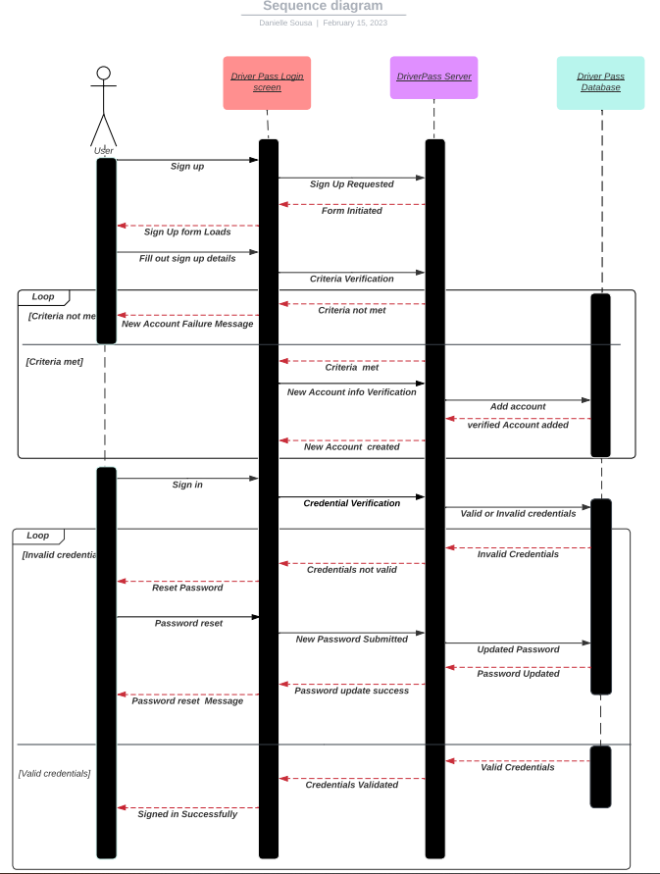

### UML Class Diagram

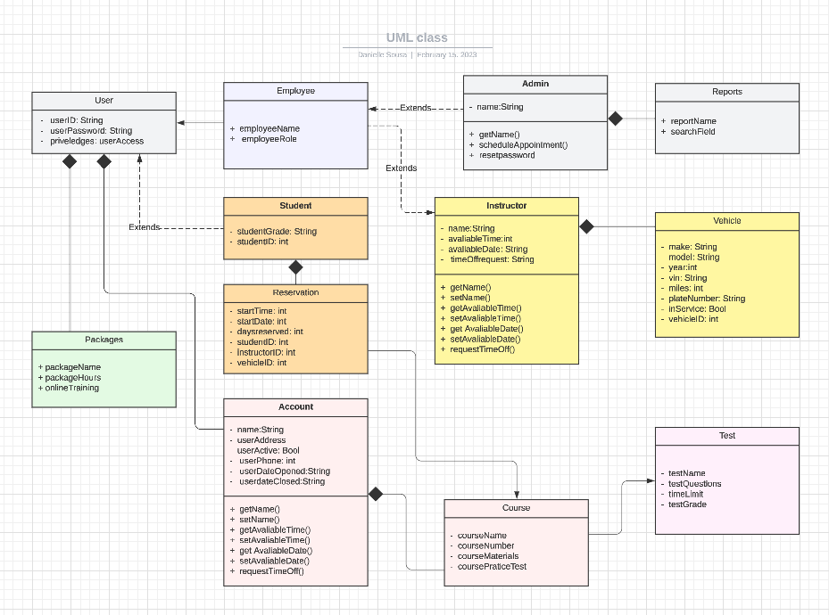

## Technical Requirements

*The following list outlines the technical requirements for web-based learning.*

1. *System shall validate user credentials Iin HTML.*
2. *Login using multifactor authentication.*
3. *System shall be web-based and be in the form of a website.*
4. *System shall run off the cloud.*
5. *Cross Platform availability.*
6. *System shall be scalable to accommodate an increased user base.*
7. *System will need to receive and accept payments by use of a payment processor.*
8. *System shall allow certain accesses to content based on user rights access.*
9. *Add closed captioning to any videos included in the system.*
10. *Obtain a domain for the web address.*
11. *Obtain SSL Certificate*
12. *Create XML sitemap.*
13. *Various browser capabilities*

*References*

*How to Accept Online Payments in 2023: The Ultimate Guide*. (n.d.). Pay.com. Retrieved February 16, 2023, from <https://pay.com/blog/how-to-accept-online-payments#:~:text=7%20Steps%20to%20Accept%20Online%20Payments%20on%20Your>

*Password And Confirm Password Validation In HTML*. (n.d.). Talkerscode.com. Retrieved February 16, 2023, from <http://talkerscode.com/howto/password-and-confirm-password-validation-in-html.php>

*Website Technical Requirements Checklist*. (n.d.). Www.whatmattersmarketing.com. Retrieved February 16, 2023, from https://www.whatmattersmarketing.com/blog/website-technical-requirements-checklist

‌